**Commodore C64 Power Supply (Replacement) Rev. 2**

**Prototype Test**

# Measurements

|  |  |  |  |  |
| --- | --- | --- | --- | --- |
| **Voltage** | **No load** | **C64** | **Full load** | **Testing** |
| +5VDC | +5.034V | +4.841V | +4.800V | Within -5% margin: ok |
| 9VAC | 10.62V~ | 10.43V~ | 10.13V~ | Above nominal: ok |

The voltages of “no load” are measured on the DIN plug of the PSU. The other measurements were done on the User Port. The C64 is a model C (ASSY 250469).

“Full load” means, that a C64 with an Ultimate II+ and a Commodore C2N Datasette are connected. The motor of the Datassette is running.

The measurements were conducted with a Fluke 89 IV multimeter.

# Oscilloscope view of the +5VDC

The +5VDC were measured at the User Port (Pin 2 and Pin1). The time division was set to 1.0µs/cm, which seems to be sufficient with a clock frequency of approximately 1MHz. The trigger was set to 4.76V (+5V – 5%).

No failure was detected. The wave form shown in Figure 1 was recorded in auto trigger mode, since the scope was never triggered.

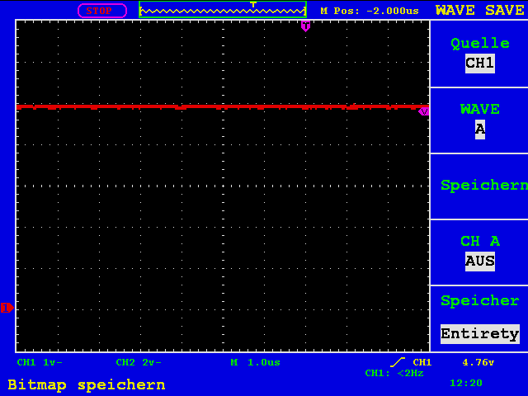

Figure 1: +5VDC, DC-Coupling (1V/cm)

Figure 2 shows the AC coupled signal. The vertical setting was 20.0mV/cm. The interferences are little (82mVpeak-peak).

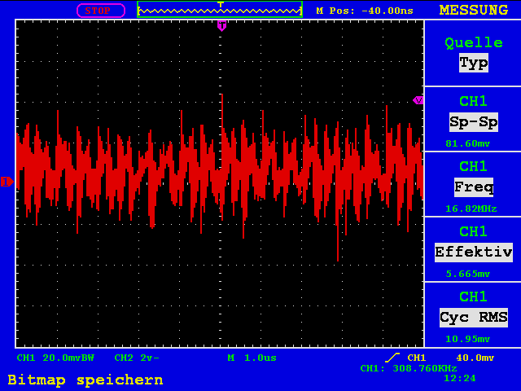

Figure 2: +5VDC, AC-Coupling (20mV/cm)

Testing: ok

The measurements were conducted with a Peak-Tech 1190 oscilloscope. The condition was a “full load” condition, the C64 was running and the Ultimate II+ was active.

# Long time testing

A long-time test over 5 hours was conducted by running the Diagnostic Rev. 586220. No failure was detected.

Testing: ok

# Thermal testing

The thermal testing was conducted under a full load condition (C64, Ultimate II+, Datassette). The components were initially at room temperature condition (25°C). A thermo couple was attached to the transformer, the case was closed except the mounting hole for the LED. It was occupied by the thermo couple. The test arrangement was running until the temperature of the transformer stabilized. This was after about four hours at 44.2°C.

Subsequently, the thermo couple was attached to the bridge rectifier. It was waited until the temperature stabilized. The reading was 45.4°C.

Finally, the thermo couple was attached to the DC/DC converter. Again, it was waited until the temperature stabilized. The reading was 47.8°C. AT this point, the elapsed thermal testing time was 7 hours. After switching off, the temperature sunk 35°C within 12 minutes.

The testing was conducted with a Fluke 89 IV multimeter and a corresponding thermo couple.

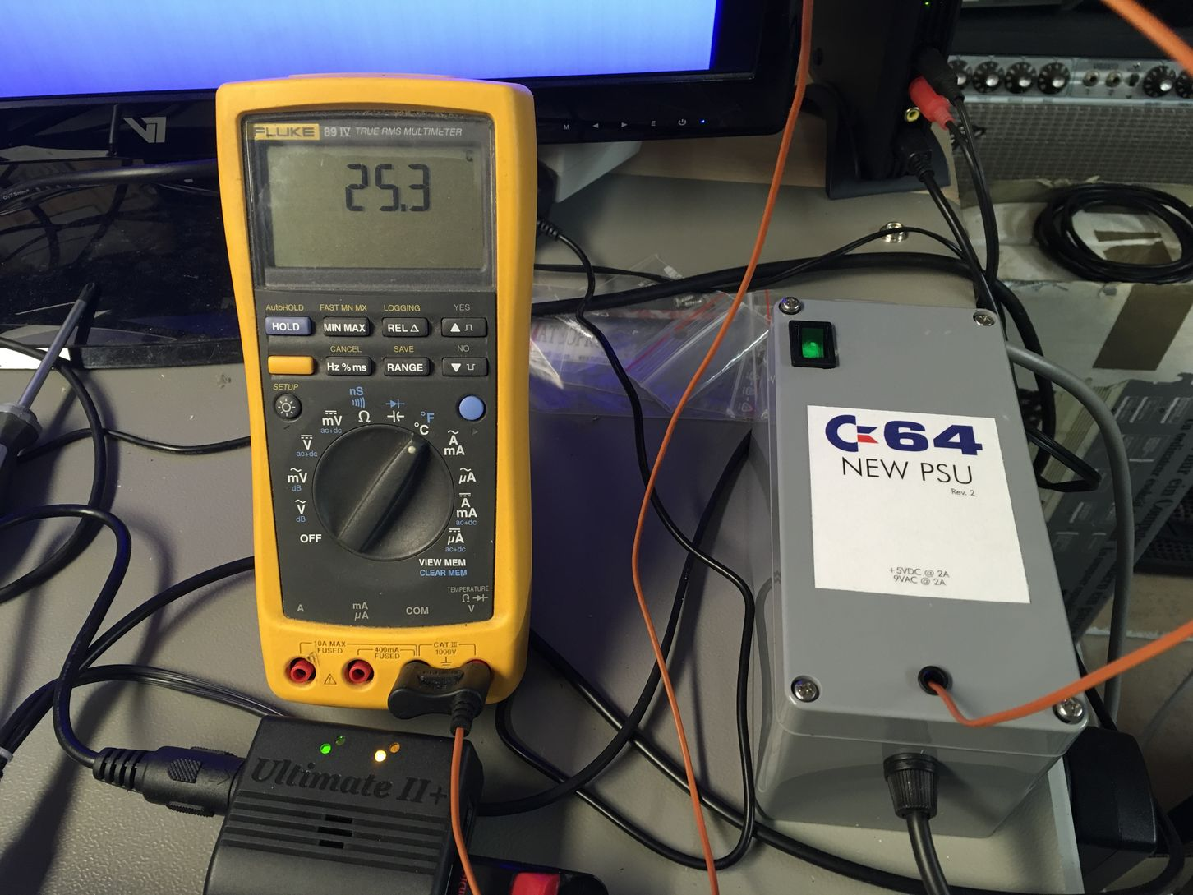

Figure 3: Thermal testing - Initial condition

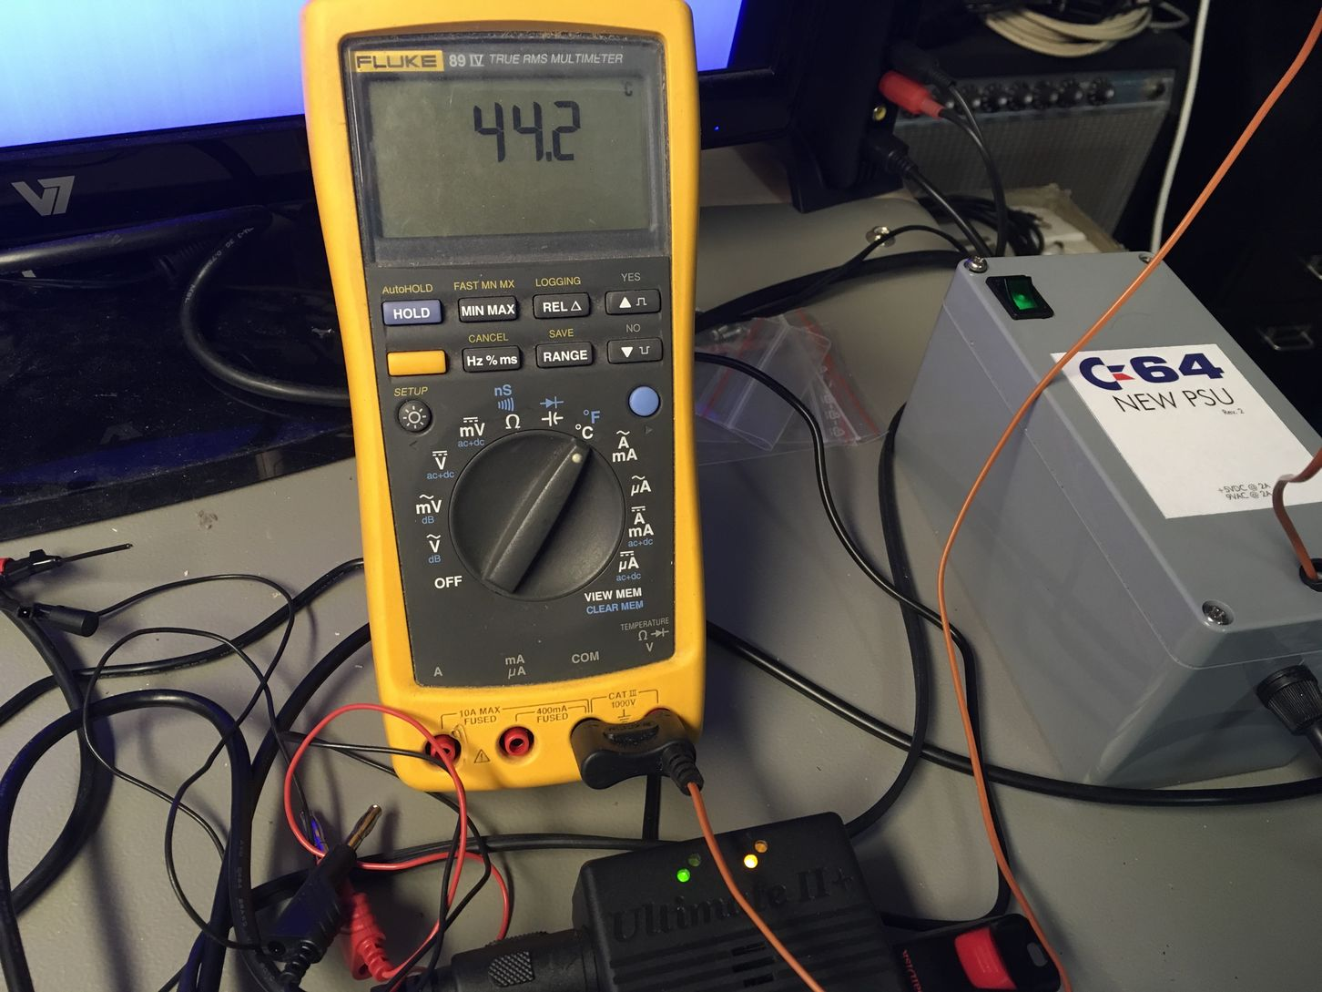

Figure 4: Thermal Testing – Transformer

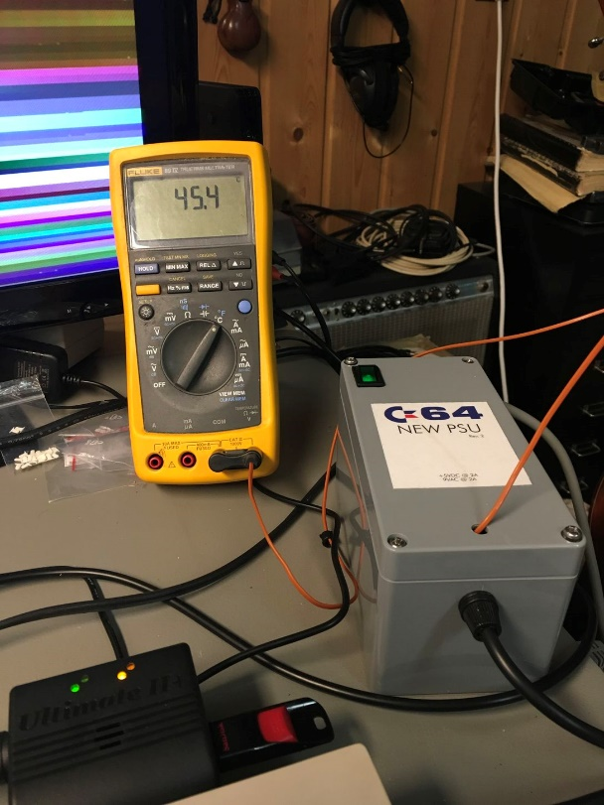

Figure 5: Thermal Testing – Rectifier

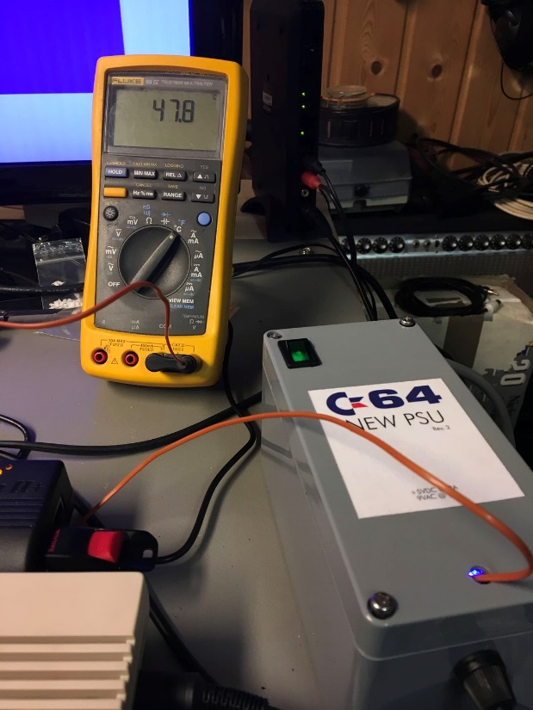

Figure 6: Thermal Testing: DC/DC converter

|  |  |  |  |
| --- | --- | --- | --- |
| Component | Measured (surface) | Rated (data sheet) | Testing |
| Transformer TR1 | 44.2°C | Tambient = 40°C | Note 1 |
| Bridge Rectifier BR1 | 45.4°C | 125°C | ok |
| DC/DC-Converter IC1 | 47.8°C | 85°C | ok |

Note 1: The surface temperature is usually higher than the ambient temperature. The temperature might not be a problem, but it is close to the temperature ratings of the transformer. **Ventilation openings in the enclosure are recommended.**

The thermal testing was not conducted under best conditions. Instead of a defined load (maximum rating) from an electronic load, an estimated practical maximum load was used. A cassette motor permanently running for hours with an inserted tape for challenging the 9VAC does not have a practical use. The power consumption of the Ultimate II+ is not constant and it might not always reach its maximum.

The ambient temperature outside the PSU was 24°C. Testing in an environmental chamber was not conducted.